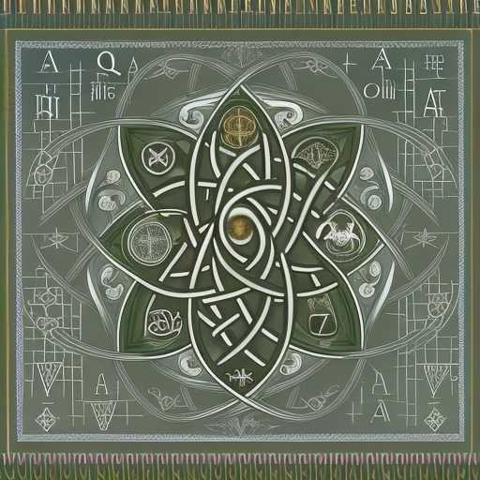
THE EAST-WEST METHOD OF SALVATION BY BENEVOLENT DELUSION

A savior complex becomes a cruci ed superego
Humility then enables actualization of the Righteous Soul - who is Wisdom’s Womb
From Her, Compassion & Truth are born as one, replacing the sun & moon as guides
Compassion falls below the moon through pride
Materialism is Cerberus
Annihilation is Buddha’s Zero
Darkness
From The Dark Night is born
New Light
Stars in the Sea
These stars are branches woven into vines of Truth
Swirling and expanding Platonic forms do battle as Angels & Demons
A double soul battles itself like yang over yin
Then, the Triumph of the Immaculata
Over the lower nature
Then a Beati c Vision
Then a Blessed Assurance
Then a Blissful Encounter
Then a union once more of Truth, through the Cross of Passion, to Wisdom
Then...
The Clouded One behind all the faces
Then...
The Stillness of Shiva’s dance
Until
Living Flames of Love Ignite
Sparks of inspiration follow
Holy emotions follow
Holy thoughts follow
Holy deeds follow
Salvi c life is led
Amoghassidhi’s Courage is Bestowed
Worlds without end
Amen

